**Final Project**

**AnishSharma Group**

**Members Name: anish sharma (c0669402)**

**romil patel (c0722847)**

**Nidhi patel (c0697935)**

**Palak parekh (c0721764)**

**Shreya shah (c0712857)**

**Main Page:**

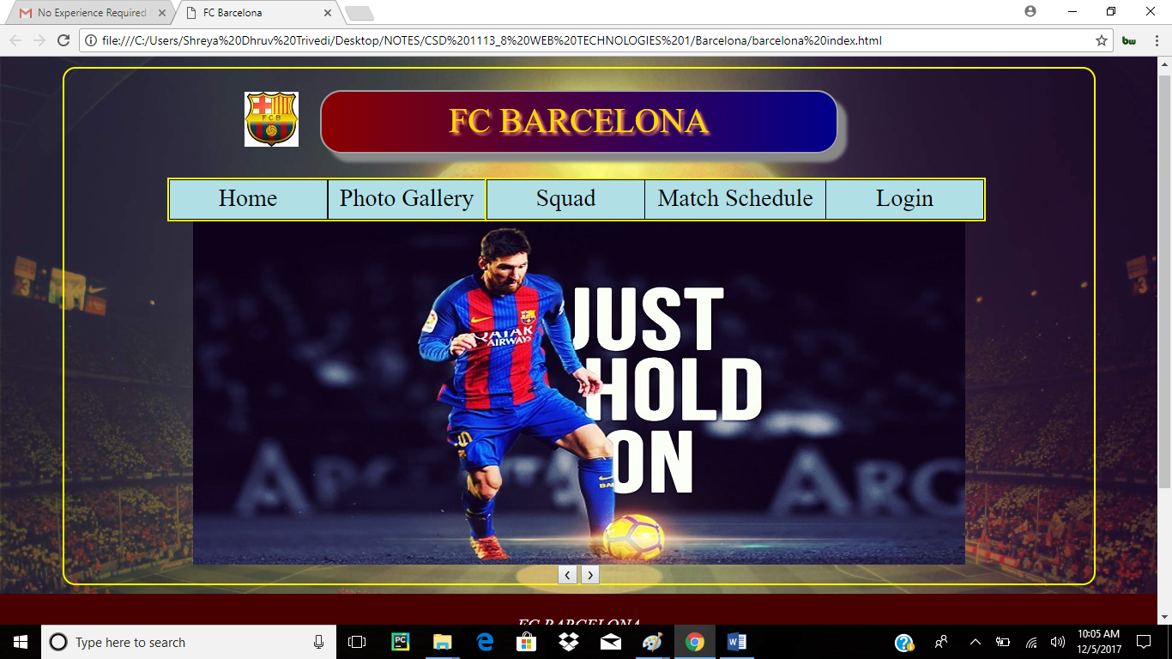

This is Main Page of our website “FC BARCELONA”. FC Barcelona is a FootBall Club Association Team and the website is on the information about it. Includes Home, Photo Gallery, Squad, Match Schedule of their Upcoming Matches And Login to register for the Ticket Booking Functionality.

Navigation bar contains all the Pages linked with it.

The main page adds the sections such as Logo and Header designing in the Header section.

The Tags which are used in the Main Page are as below :-

1. div – For the elements to set in the sections.
2. Img – Img tag is used to set the image of the logo.The filename of the image source is specified in the src attribute.The height and width attributes are set through CSS.
3. Button tag – We have used button tag to for the slider left and right buttons.
4. Each section contains classes and ID’s.We have linked the external CSS to set all the header, footer design.
5. We have used a small code of the javascript slider.

**Registration Page** **:**

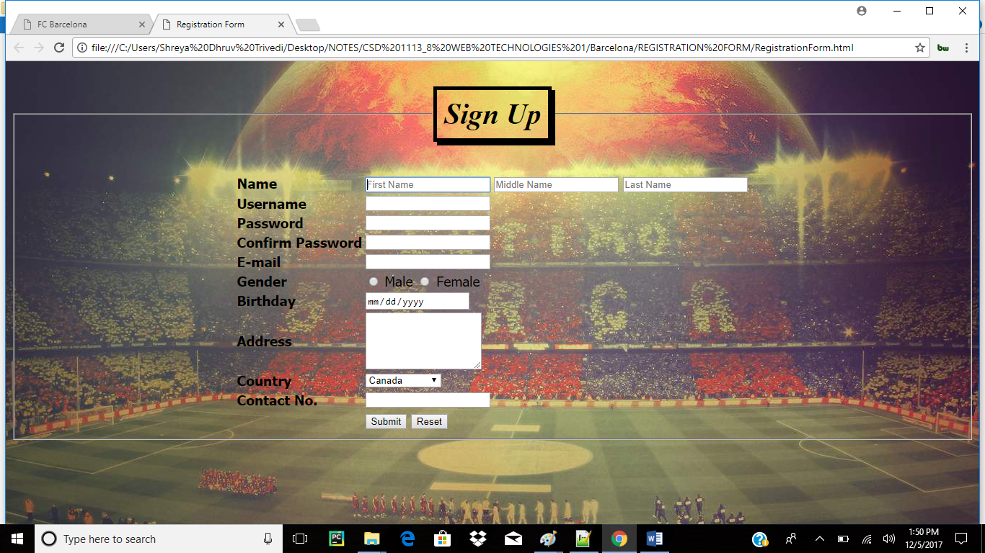

Tags used in Registration Page are :

1. Input – This tag is used for the type of element used.In this we have used Text, Button, Radio Button etc. we have also used validation.
2. <td> - It defines standard cell in an HTML table.
3. <tr> - It defines row in an HTML table.
4. External CSS is used for the designing of the page and the elements by classes.

**Aboutus.html :**

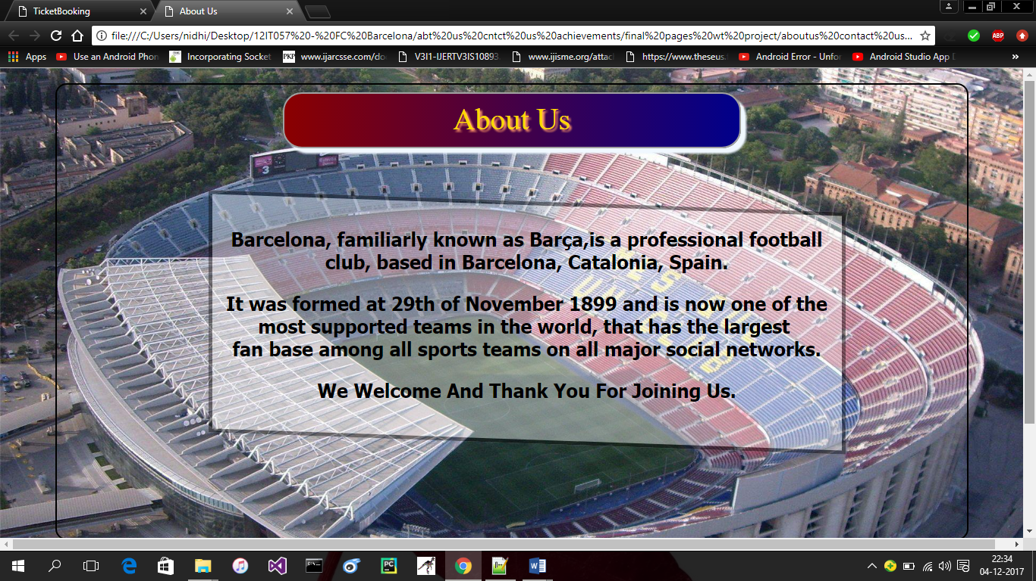

This is “About us” page of our website.

About us page gives the information about this club and its history.

Aboutus page contains body element, center element, footer element , paragraph element .

This page uses the external css type. The abtus css contains css properties for background ,margin,border,font and position.

**Contactus.html**

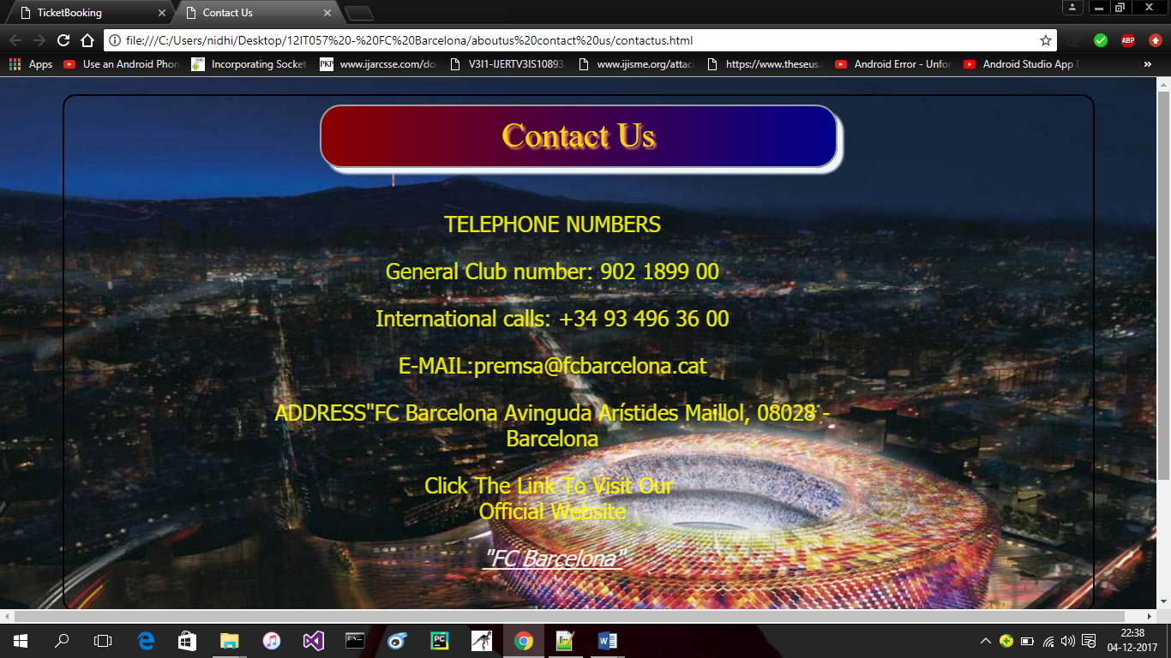

This is “contact us” page of our website.

Contact us page gives the information about the helpline numbers and address so users can get help easily.

In contact us page we have used center element ,paragraph element ,footer element and in this we have used external css .

In external css we have used background properties , margin properties , font properties .

**Achievements.html :**

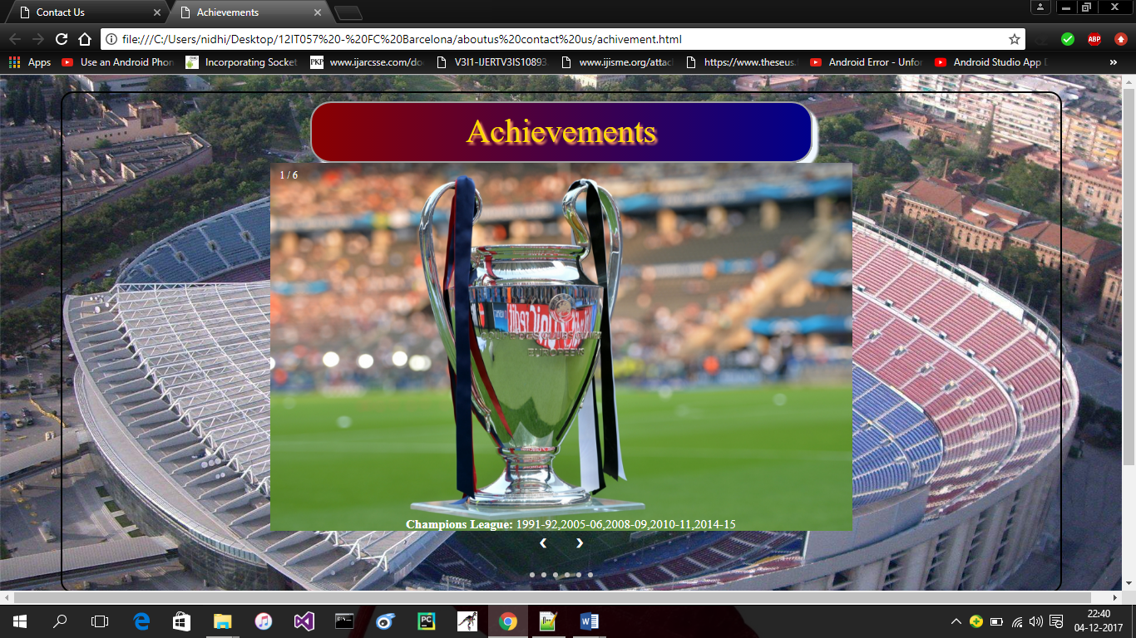

This page is the “Achievements” page of our website.

This page contains the information about titles the FC Barcelona team won.

This page contains center element, header element, img element, footer element, bold element, break tag.

In this page we also external css and in css we have used margin , background , font , border, class selector, id selector.

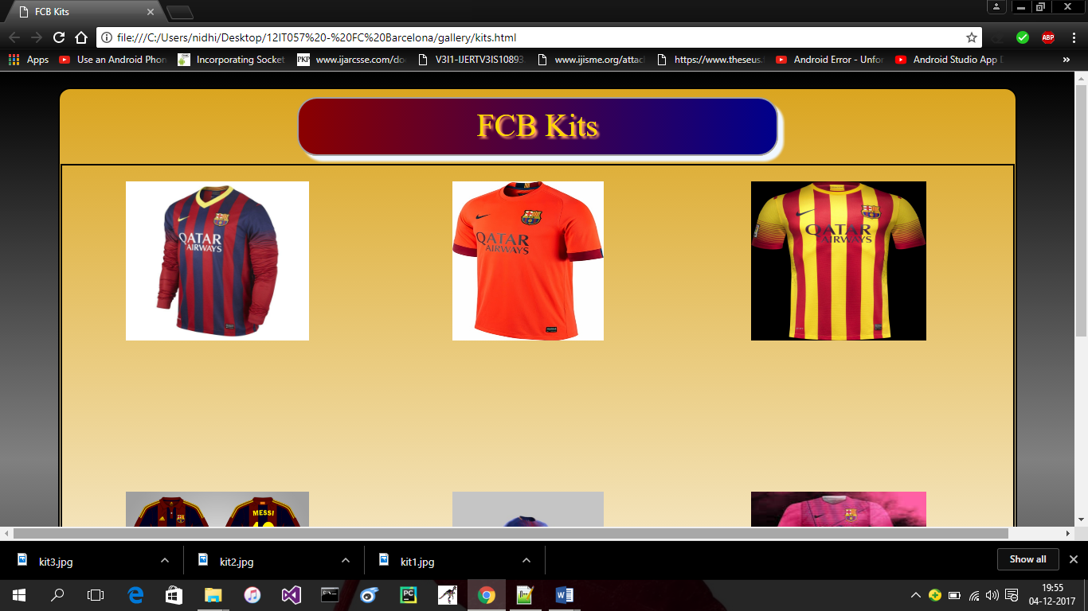 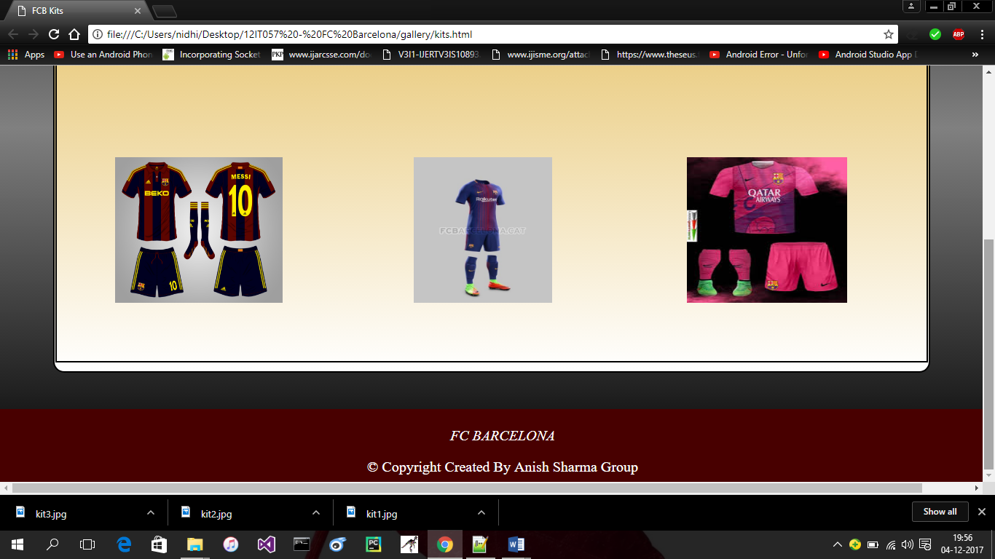

**Kits.html**

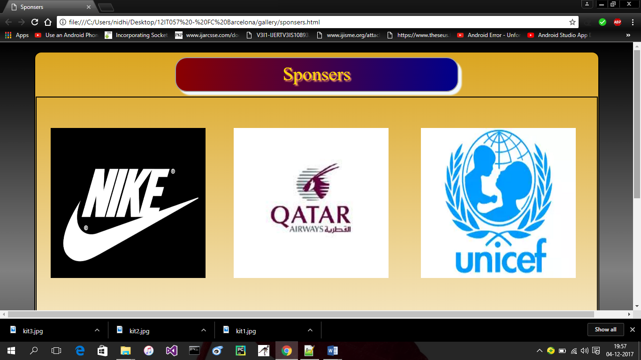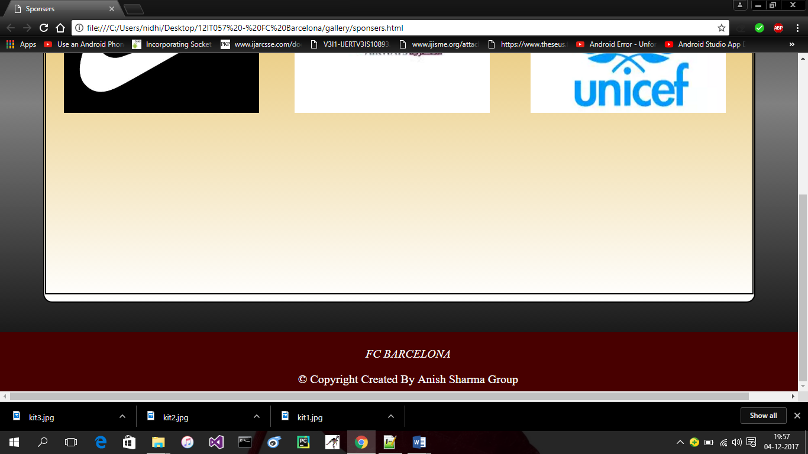

**Kits.html and Sponsers.html**

Kits.html page contains picture of member’s kit. This page uses title tag to give title to the page, link tag to add css file, script tag to link javascript file, body tag, header tag, footer tag.

Javascript file is used to call function named onMouseOver and onMouseOut by getting element’s id.

CSS file contains various properties to style the elements like, border, box, margin, float, text, font, padding.

Here in our project FC BARCELONA FB CLUB we make many pages like about us, sponsor’s, kits, team members and scout members with login and ticket booking page.

But here I describe details of Squad page. In this section we make two more pages in sub directory.

1. Team Members
2. Scout Members

In Team Members page all team members of the team like goalkeeper, Defenders, Midfielders, Forwards.

The below here I mention figure of scout members front page.

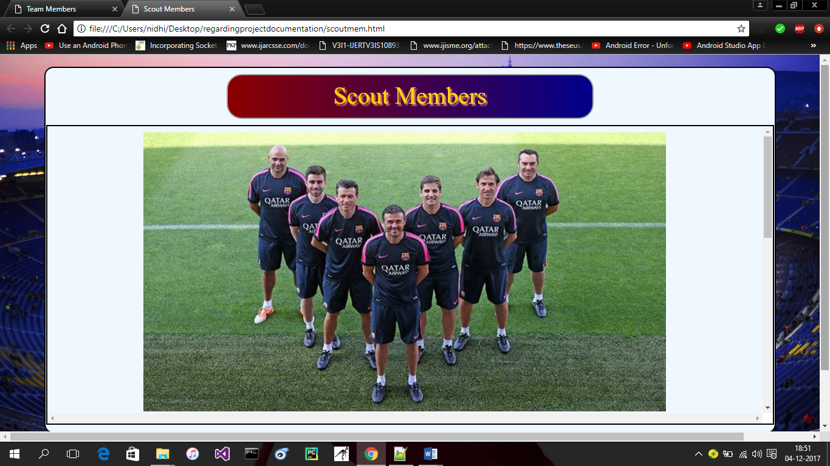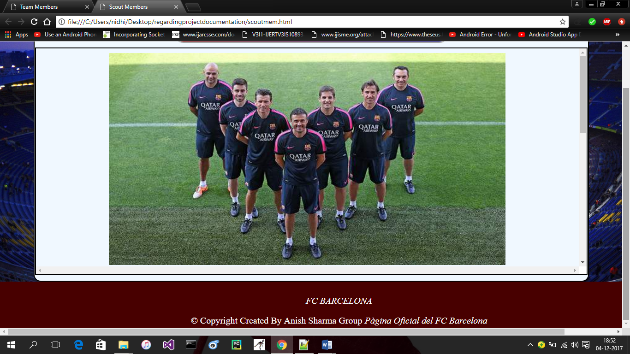

**Scoutmem.html:-**

The above figure mentions the scout members. In this page we display supporting staff of club. Here is main image display all supporting staff and below some about details of staff and crew members.

**Teammem1.html:-**

The below page is Team Members page with all members like goalkeeper, Defenders, Midfielders and forwards. Here is front look of this page.

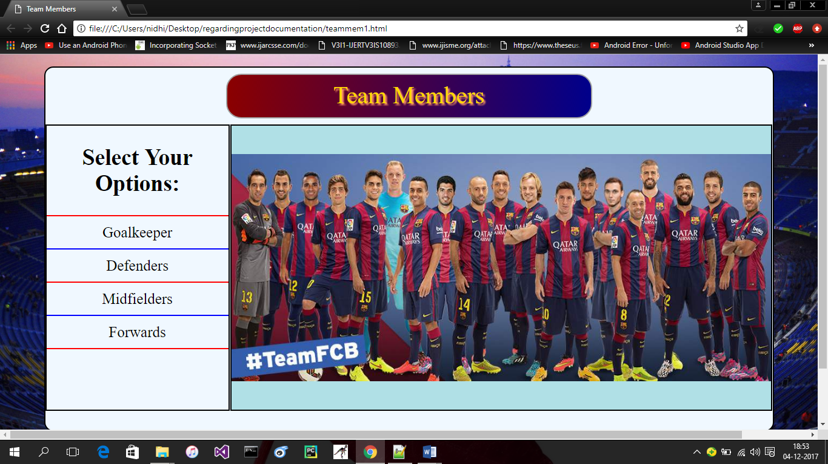 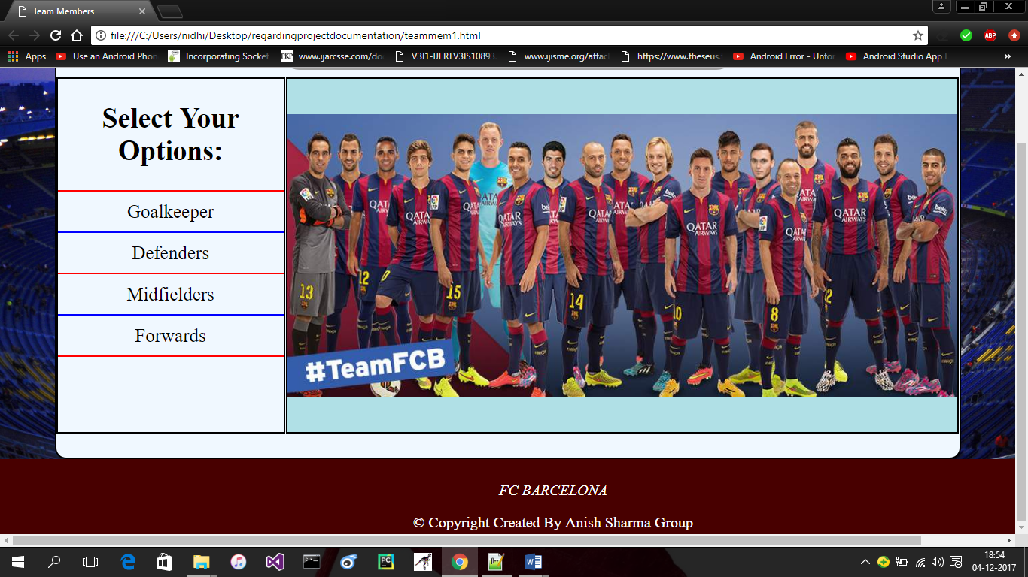

**Goalkeeper:-**

The below figure is display goalkeeper of team with its all detail. Here is specify only GoalKeeper section.

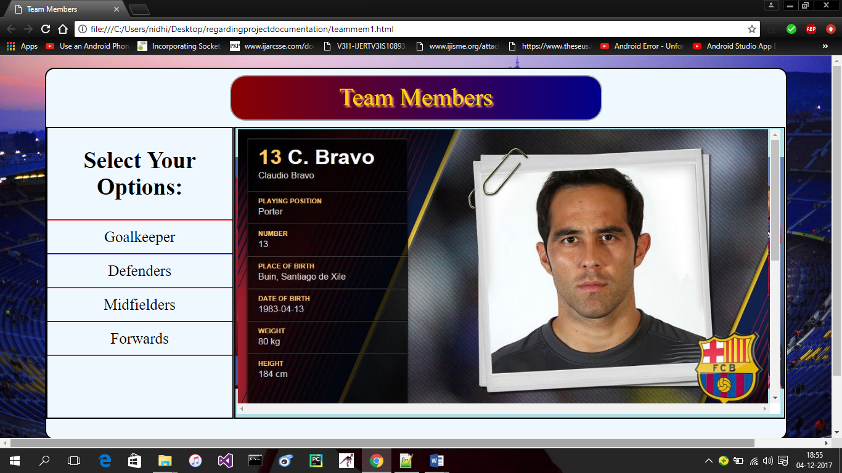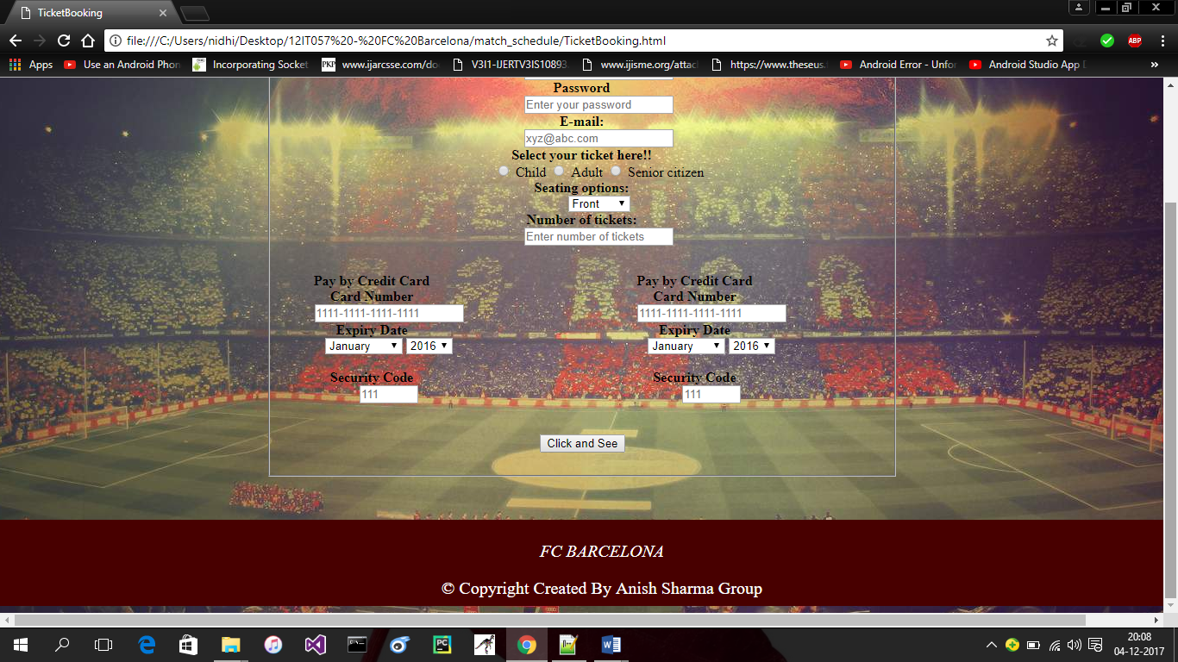

**Defender:-**

Here same we put defenders page look with its all members and details of players.

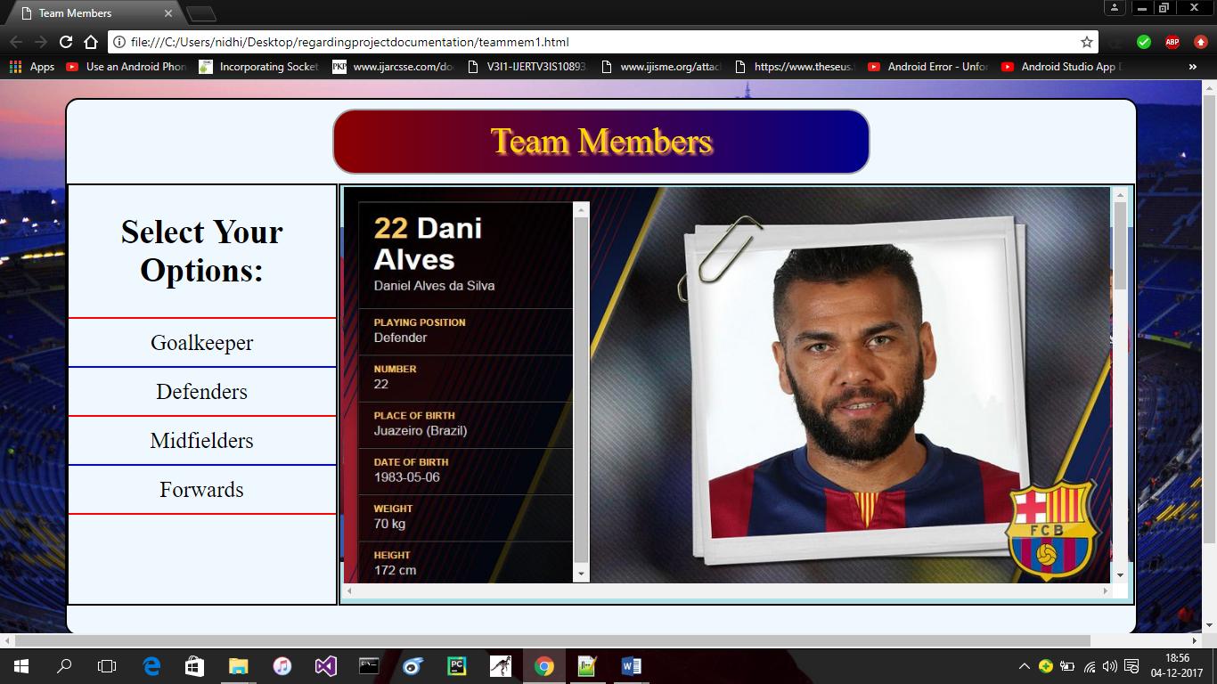

**Midfielder:-**

The below figure mentions Midfielders of team and full details of team.

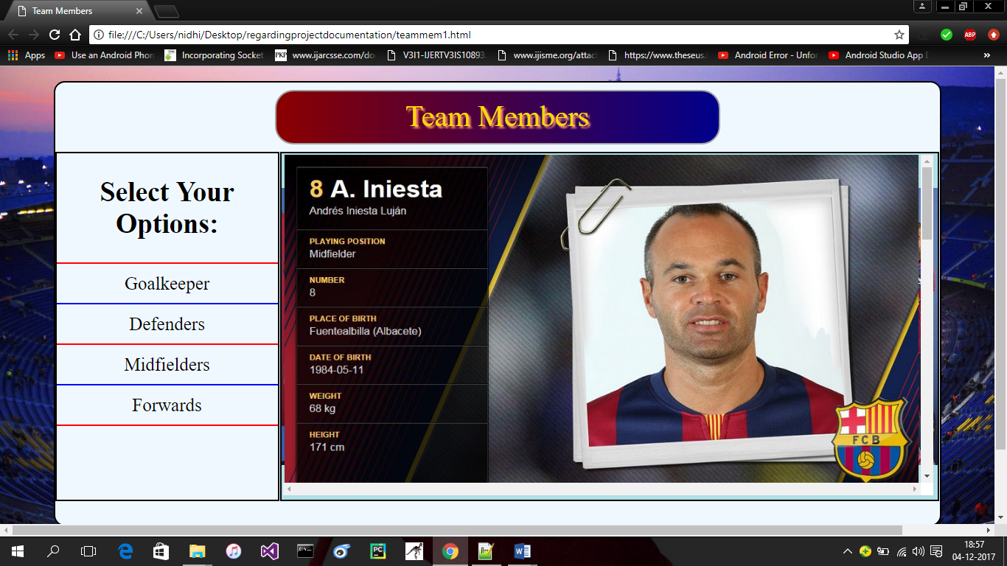

**Forwards:-**

And last page in team members is Forwards with all full details of players.

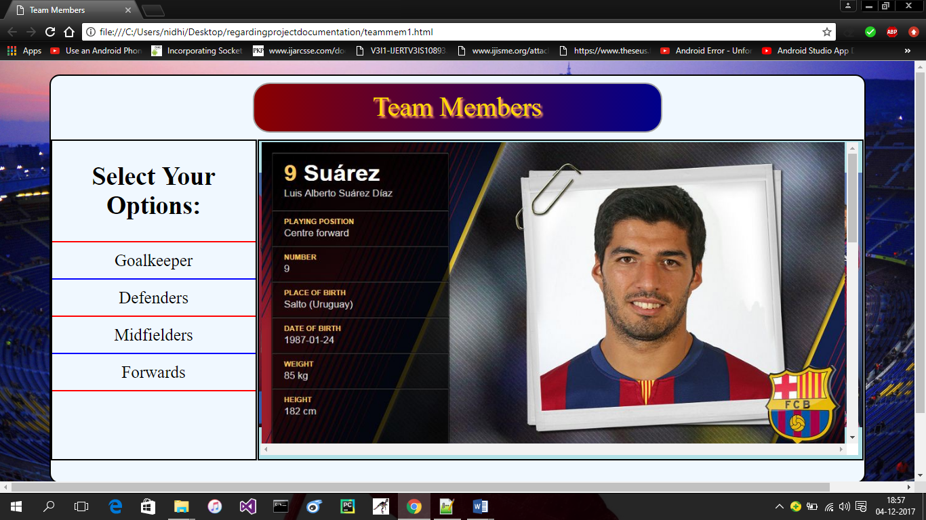

And in this project we use Html , CSS and java script.

Here I mention HTML tags.

1. **Head**: Head Tag is used for giving heading to our page.
2. **Meta**: This tag provides metadata about html page. Meta elements typically used to specify page description, keywords, author of document.
3. **Title**: Its define title in web browser or provides a title of page.
4. **Link**: The link tag defines link between document and external resources.
5. **Script**: This tag is used to define client-side java script.
6. **Nav**: This tag defines navigation of links.
7. **Hr**: This tag is used to provides space link horizontal.
8. **Image**: Img tag is used to specify image in web page.
9. **Footer**: footer provides specially footer in web pages.

A <footer> element typically contains:

* authorship information
* copyright information
* contact information
* sitemap
* back to top links
* related documents

1. **span**: This tag used for group inline elements in document.
2. **<i>:** italic word or sentence.
3. **<p>:** This tag is used to create for paragraph for sentences.

Here I also used java script.

The **getElementById()** method returns the element that has the ID attribute with the specified value.

Returns null if no elements with the specified ID exists.

An ID should be unique within a page. However, if more than one element with the specified ID exists, the **getElementById()** method returns the first element in the source code.

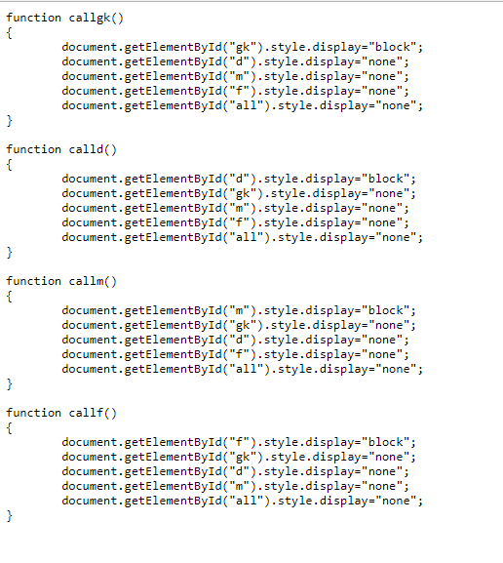

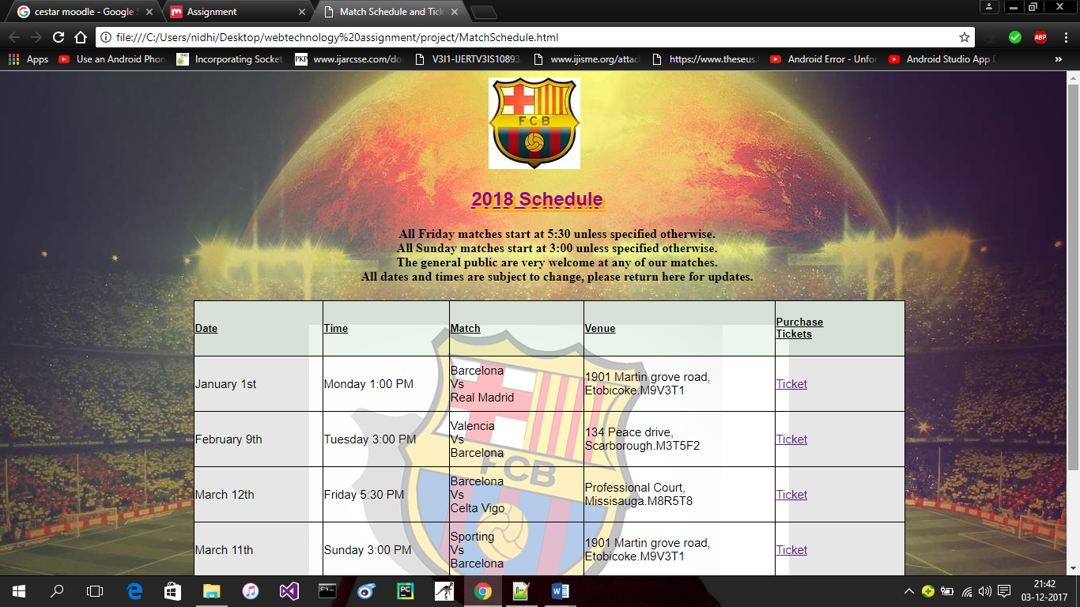 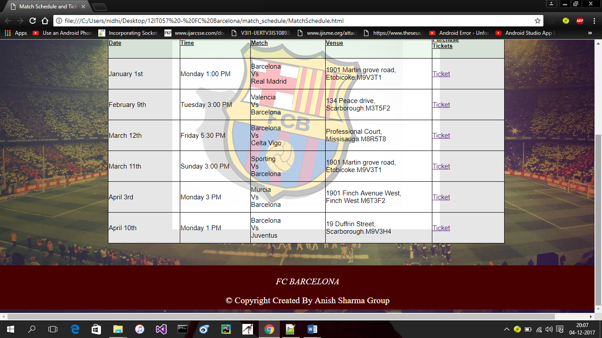

**MatchSchedule.html:**

Match Schedule page contains HTML tags like: body, article, table, style, head. It contains css properties for background, margin, border and position.

This page describes the match schedule for upcoming matches, their date, venue and the link for book the ticket.

This page redirects on another page after clicking the Ticket link as below.

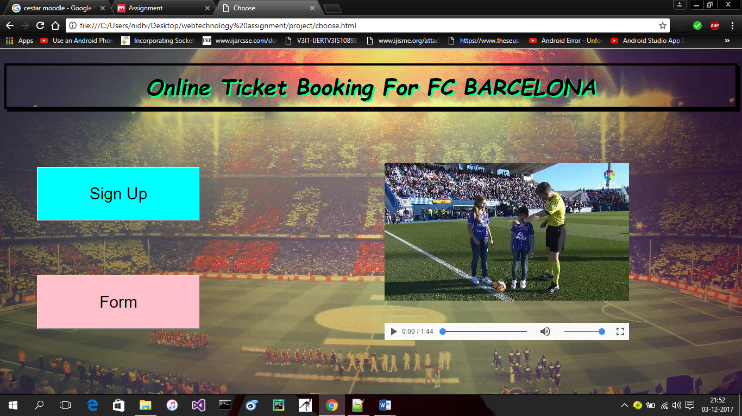

**Choose.html:**

This page contains title element, style element, body element, heading tag, div element, video tag, script tag to hold the javascript function.

It uses the css styles for background, border, text, element’s position, color.

Two buttons Sign Up and Book your ticket redirects to two another pages Registration form and the Ticket booking page.

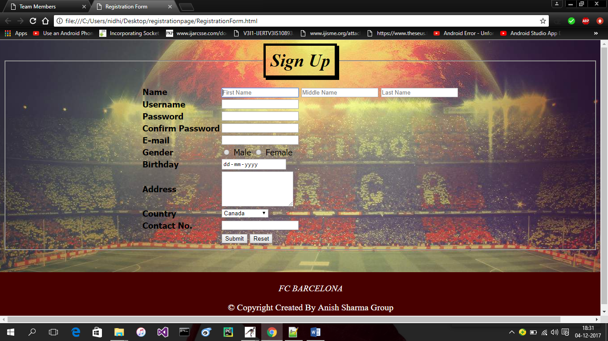

**RegistrationForm.html:**

Registration form contains title element to give title to the page, style element to hold the css properties, body element, form element to hold the whole form, table element, fieldset to group different form elements and legend tag to give title of the fieldset.

Two buttons submit and reset will submit and reset the entered information to the server.

It uses the css style to set the background, padding for element’s content, border, and font.

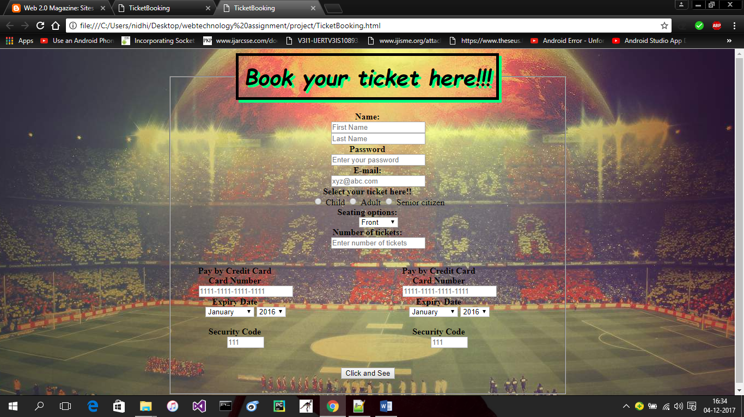 

**TicketBooking.html:**

Ticket Booking page is used to book the tickets for upcoming matches. For that first user have to register themselves in Registration form and after that they can use their password for ticket booking page. Once the user click the button click and see they will redirect to another page welcome.html.

This page contains css properties for text, background, border.

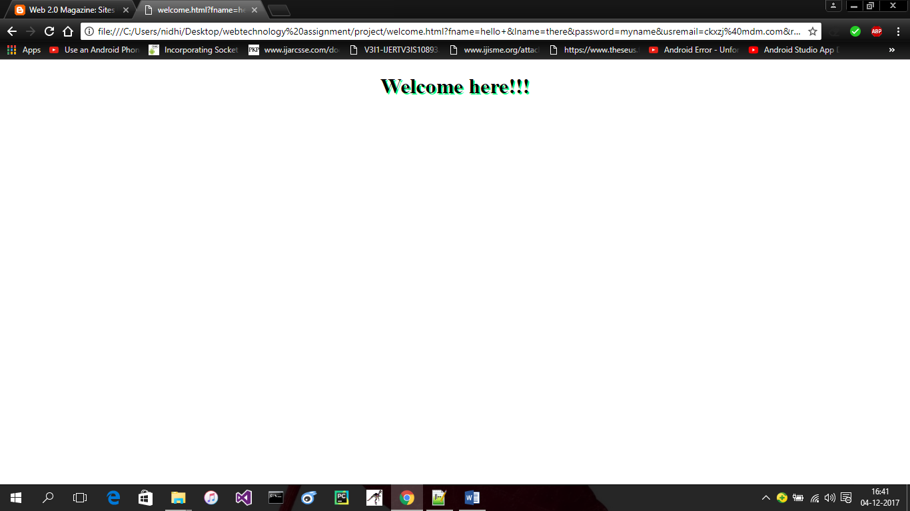

**Welcome.html:**

This page contains only one heading tag. And css properties for text. This page will open when user will enter information and click the button click and see on TicketBooking.html.